Exercise 1(A) - In-Lab Task (SIMULINK)
1. Mechanical System 1
2. Electrical System 2
3. Electromechanical System 3

1. Mechanical System
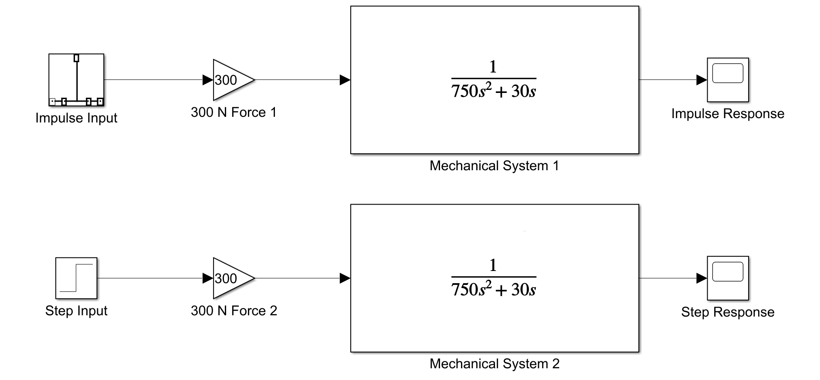
SIMULINK Model
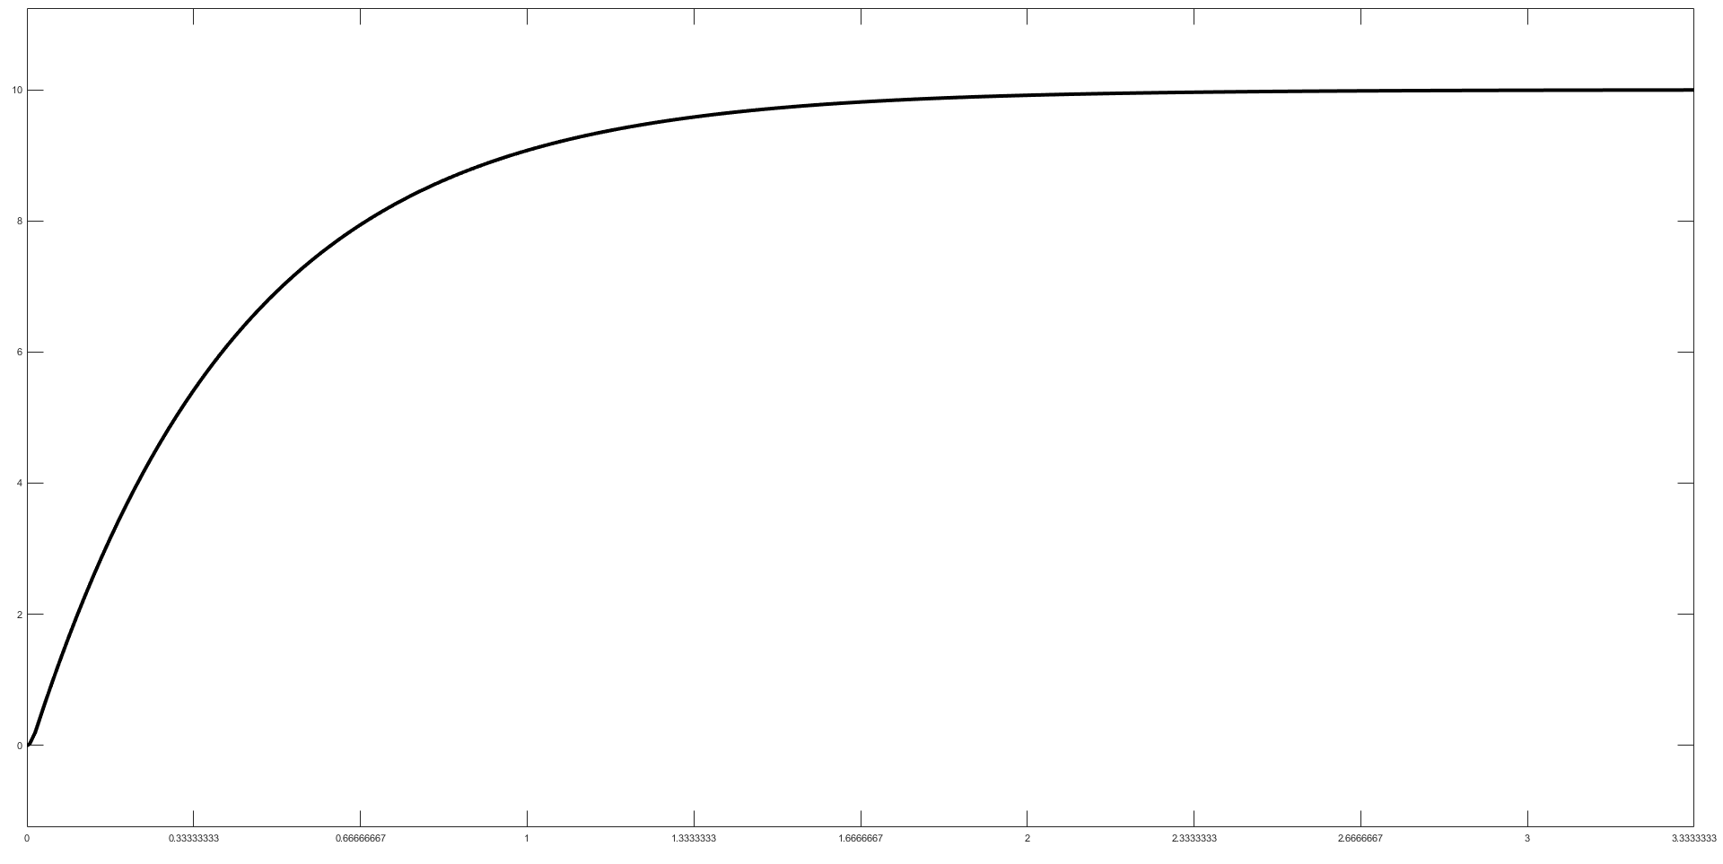
Impulse Response
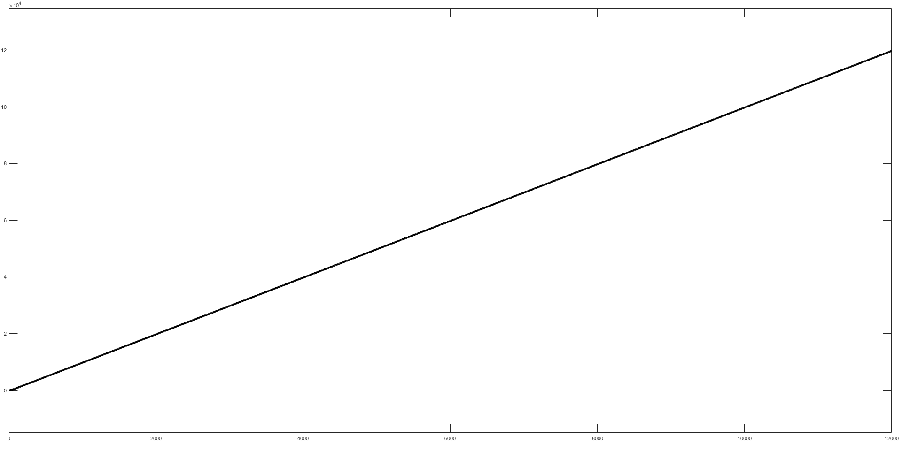
Step Response

2. Electrical System
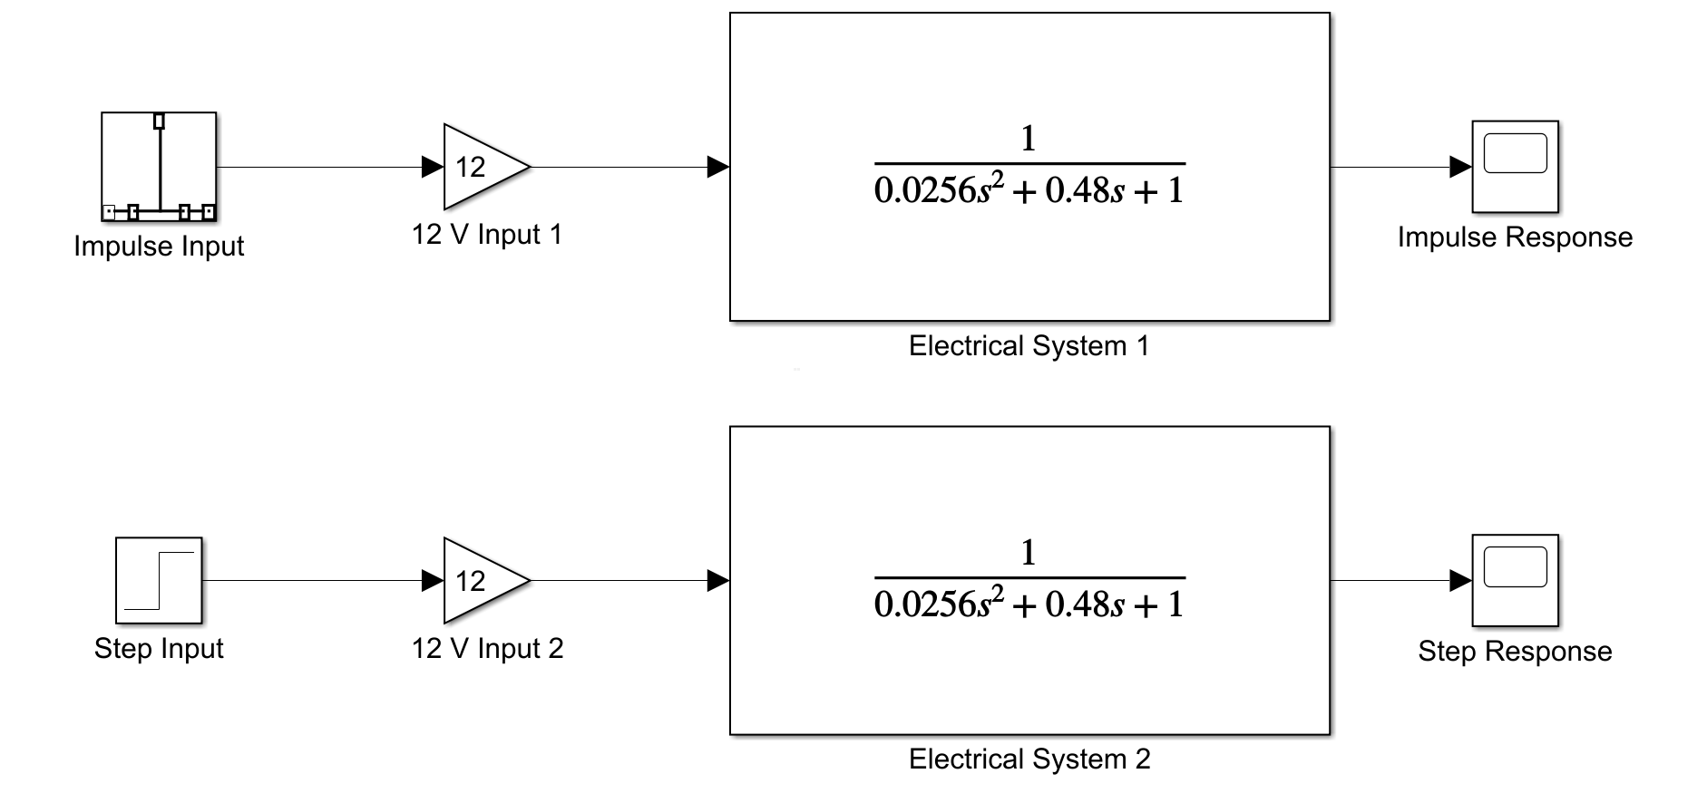
SIMULINK Model
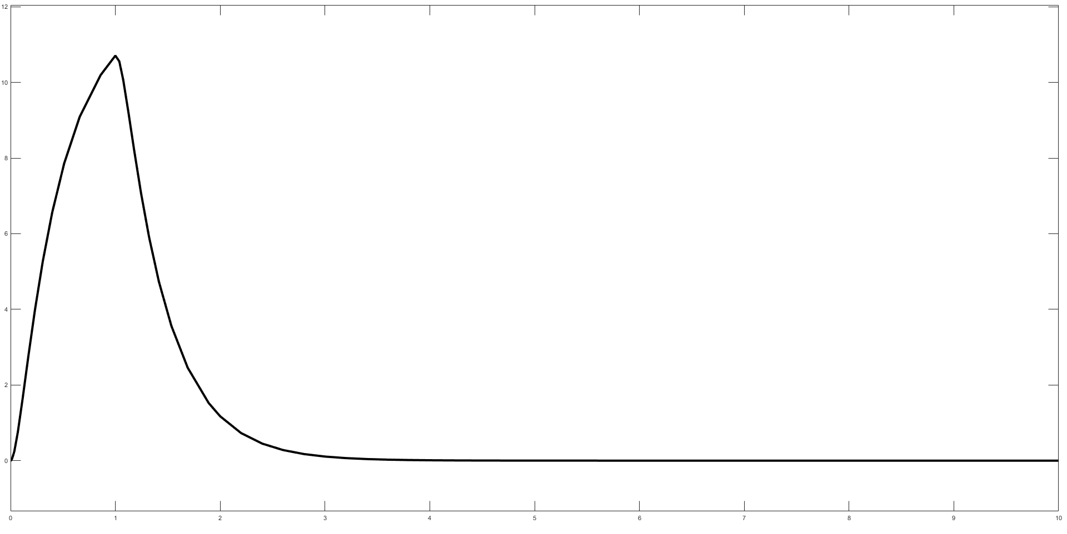
Impulse Response
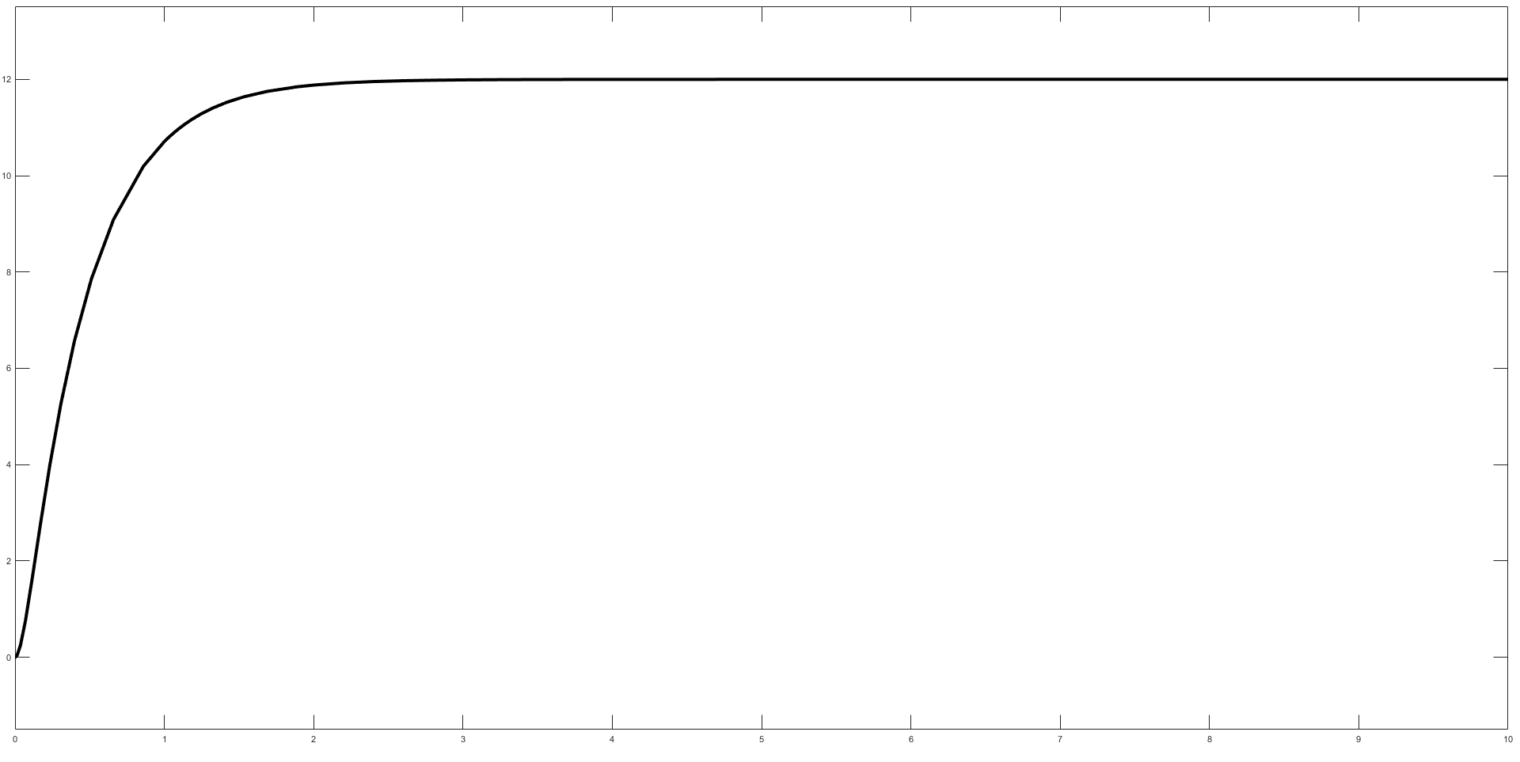
Step Response

3. Electromechanical System
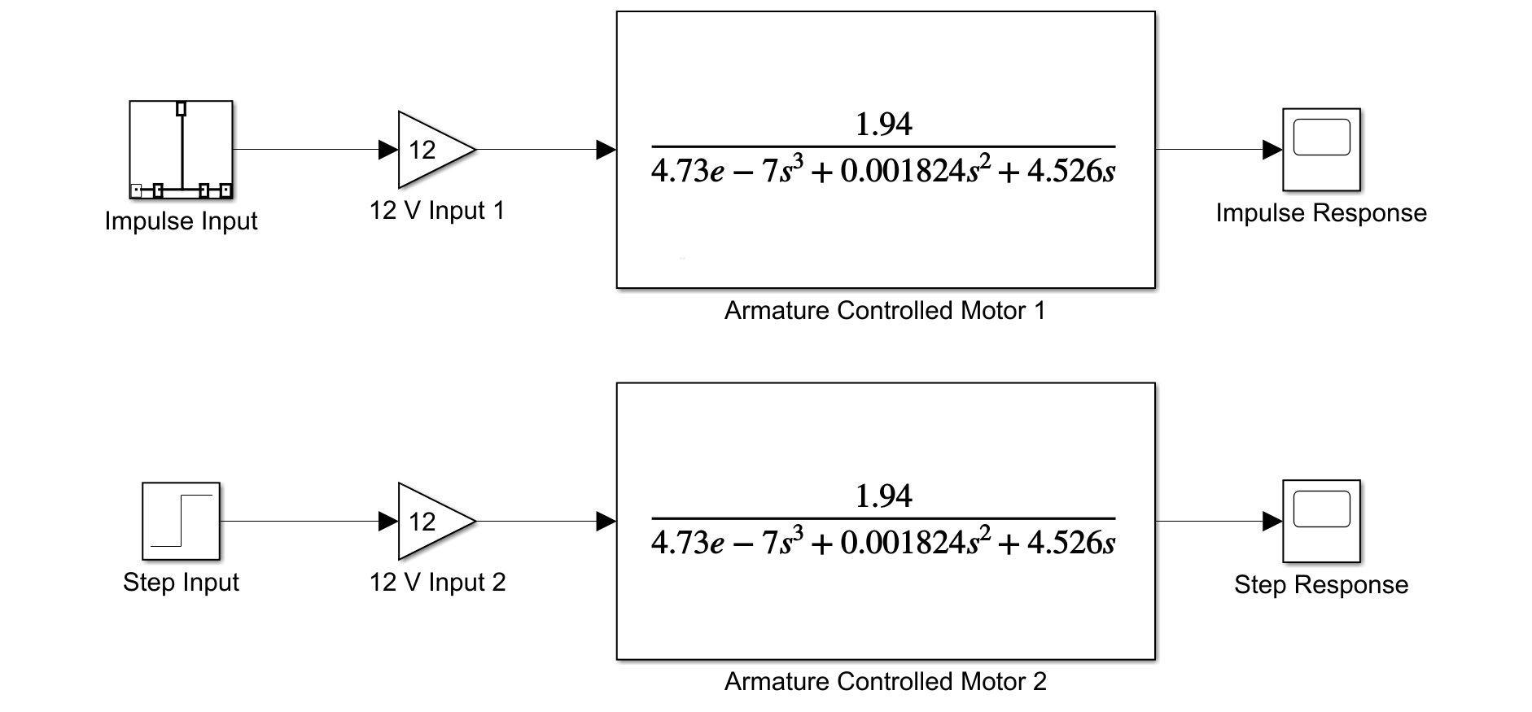
SIMULINK Model
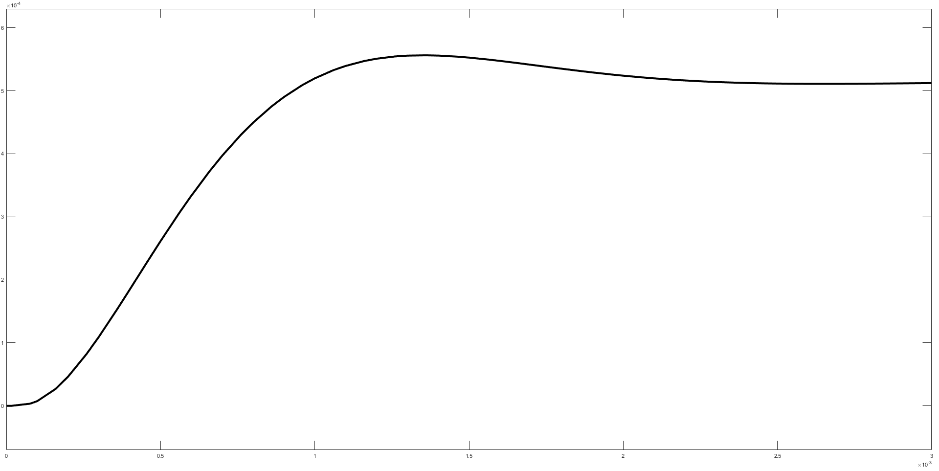
Impulse Response
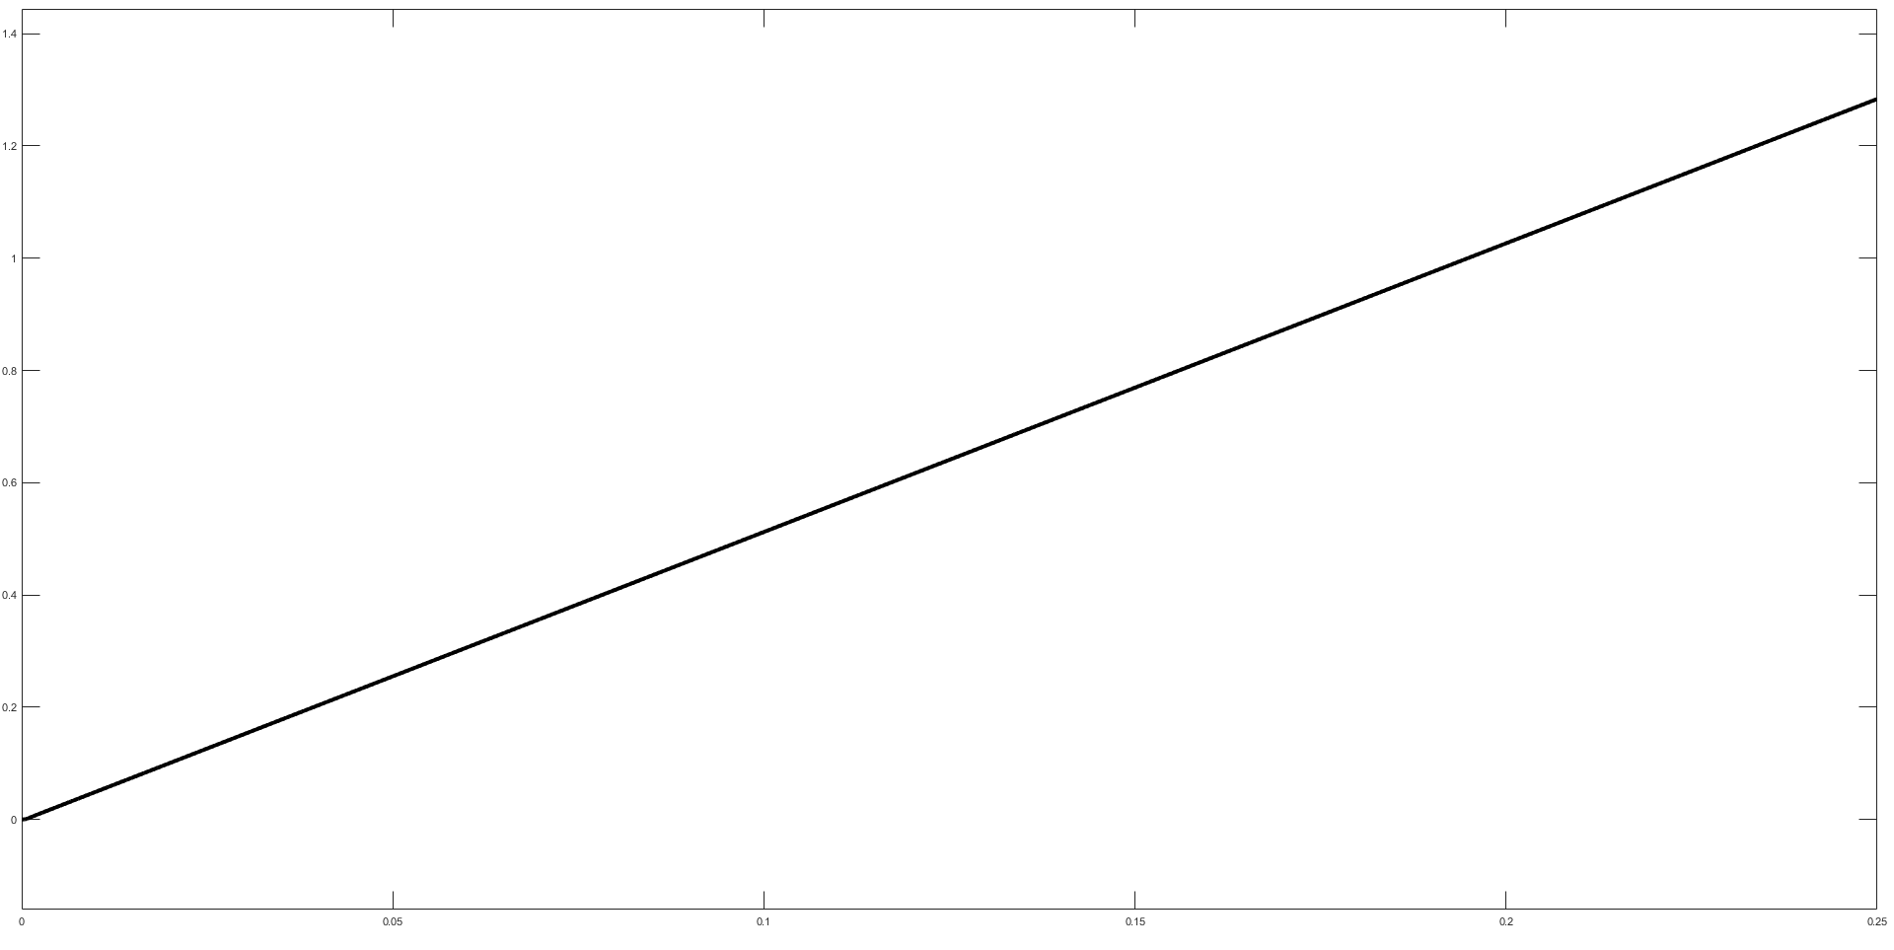
Step Response

